

FACULTY OF INFORMATICS &
DESIGN
Project Management 3

Submission date: 16 May 2026

Group WO1

Student name | Student Number | Course Code
Jada Rinquest | 222871296 | 372s

These are our figma wireframes ,not all the group members in the group completed their wireframes yet. But I was responsible for the profile page.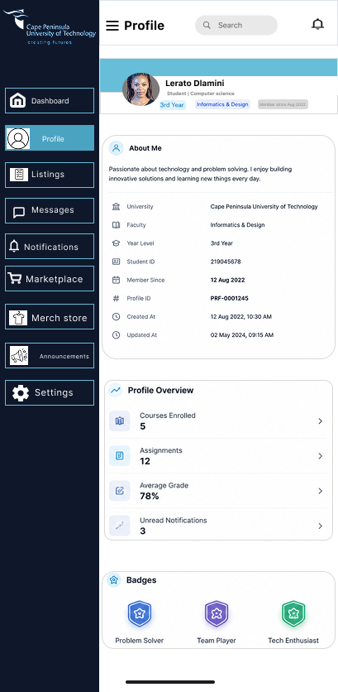
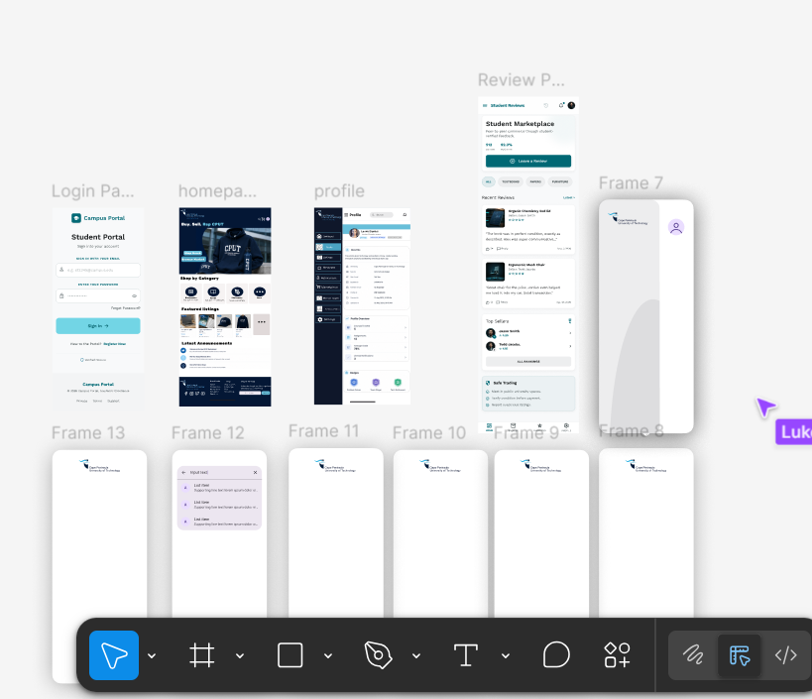

Reflection
For this phase of the project, my responsibility was the design and planning of the Profile Page for our campus application system. My contribution included creating the wireframe in Figma, helping structure the ERD for the profile module, and analysing the business rules related to users, profiles, notifications, reviews, and messaging. The profile page was designed to give users a clean and user-friendly interface where they can manage and view their personal information.
When designing the wireframe in Figma, I focused on creating a layout that was modern, organised, and easy to navigate. The sidebar navigation was added to help users move quickly between sections such as Profile, Listings, Messages, Notifications, Marketplace, and Settings. I also included profile statistics, badges, and an “About Me” section to make the page feel more interactive and personalised. The design aimed to balance functionality and simplicity while still maintaining a professional appearance.
The ERD for the profile section was developed based on the system requirements and business rules provided by the group. I focused specifically on the entities related to the profile module, including User, Profile, Notifications, Messages, Reviews, and Listings. The relationships between these entities were important because the profile page interacts with multiple sections of the application. For example, one user can have many notifications, listings, and messages. I also ensured that the business rules supported the relationships shown in the ERD, such as each profile being linked to one user and profile information being editable. Shuttle tracking and GPS-related entities were excluded from my section because those features were assigned to other group members.
One of the challenges I experienced was ensuring that the profile module connected properly with the rest of the application without overlapping too much with other members’ work. I needed to make sure my section was detailed enough to show functionality, while still staying within the boundaries of the profile page responsibilities. Another challenge was designing the wireframe in a way that looked visually appealing but was also realistic and practical for implementation.
Through this process, I improved my skills in UI/UX design, database planning, and understanding entity relationships. I also gained more confidence using Figma to create structured wireframes and learned how business rules influence the design of an ERD. Overall, this task helped me understand how different parts of a system connect together and the importance of planning before development begins.

